Name:

Part 0 – In google, enter the following “Software Testing Jobs Chicago”. Find 1 job.

In your own words … what are they looking for?

List the specific technologies/skills that are needed.

Report back to the group …

Part I – What are the test cases do you recommend?

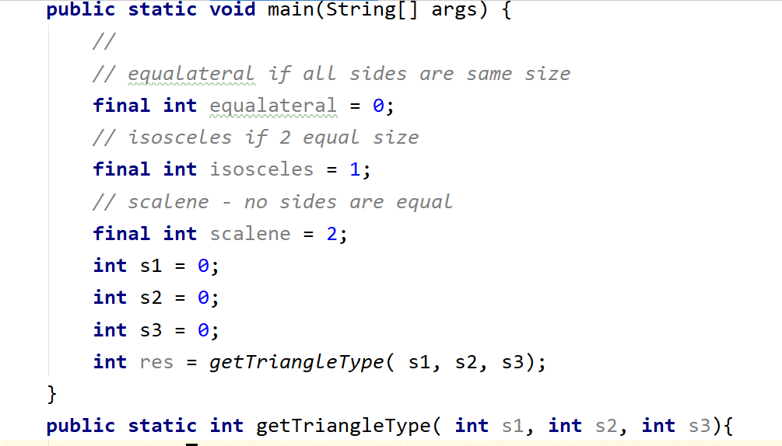

What test cases you would recommend to consider the getTriableType() method well tested?

Part II – How many combinations?

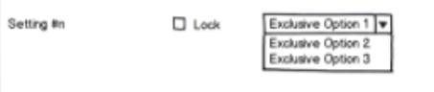

How about this UI?

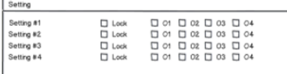

And finally the 2 combined?

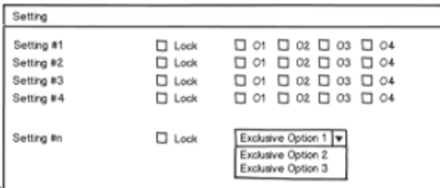

Part III – Develop a set of test cases that covers all of the statements in the following method:

1. def print_sum( a, b ):
2. result = a + b
3. if result > 0:
4. print( f“Red:{result}”)
5. else if ( result < 0 ):
6. print(f“Blue:{result}“)